Development House
56 - 64 Leonard St
London EC2A 4LT

Tel: 44-20-7065-0775
Website: www.peacebrigades.org
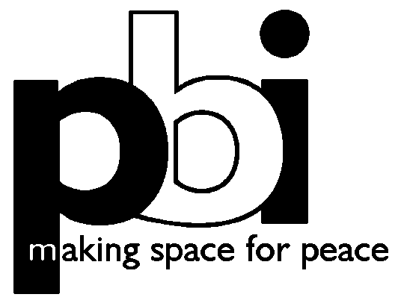

October, 2008

Dear Applicant

Re: International Finance Manager

Thank you for your interest in the position of International Finance Manager at Peace Brigades International (PBI).

This is an exciting new post that combines general financial administration responsibilities with a policy role overseeing and developing global financial strategies.

In an organisation deeply committed to consensus decision-making processes and to the active participation of volunteers and staff, the finance manager will have the opportunity to work with diverse parts of PBI, including not only our central office and governing board but also our field projects in Colombia, Indonesia, Mexico, Guatemala and Nepal and our network of 16 country groups who support the projects. In every corner of the organisation, the finance manager will encounter deeply committed, inspired and hardworking people.

Enclosed in this e-application pack you will find the following:

* Background information to PBI international structures
* Job description
* Person specification
* Application form
* Equal opportunities monitoring form

You will find more information about PBI and a copy of our 2006 Annual Report on our website at www.peacebrigades.org.

Please complete the application form and return by email (if you wish to send it by mail please complete the application form in blue or black ink as it will be photocopied) by the deadline of 12 noon on Thursday 23rd October 2008, marked Private and Confidential to:

Cinzia Cimmino
International Office
Peace Brigades International
Development House
56 - 64 Leonard St
London EC2A 4LT
admin@peacebrigades.org

Short-listing will be based on application forms only. Please also note that you will need to be a citizen of the EU or hold a valid working visa for the UK in order to be considered for short-listing as PBI is unable to secure such visas.

Interviews will be held during the week starting October 27. Candidates invited for interview will be notified shortly after the deadline for applications. As PBI works with limited resources, we regret we are unable to contact applicants who are not short-listed for interview. Please assume that you have not been short-listed if you have not heard from us within two weeks of the deadline.

Thank you for your interest in this post. We look forward to hearing from you.

Yours faithfully,

Cinzia Cimmino
Administrator

Notes on PBI’s internal structure

What does PBI do?

"The physical presence of PBI at the human rights trial gave us the feeling of security and moral support. For us, and especially for the victims of torture, PBI's presence reminded us that the international community had not forgotten us." Maya, Legal Aid and Human Rights Association (PBHI), Indonesia

PBI has been working to protect human rights and promote non-violence for the past 27 years. On request, we send teams of international volunteers to areas of repression and conflict to provide a protective accompaniment to local human rights defenders whose lives and work are threatened by political violence. Our work is based on the principles of non-partisanship and non-interference in the internal affairs of the organisations we accompany. We believe that lasting transformation of conflicts cannot be imposed from outside but must be based on the capacity of local people to build a genuine peace. The PBI model has proven that this external presence can deter violence and thus create greater space for local activists to carry out their work. In addition to accompaniment, PBI also carries out workshops, training and peace education work, with the goal of strengthening local capacity for conflict transformation.

PBI structure:

Country groups/associate groups in 16 countries form the foundation of PBI and are responsible for recruiting and initial training of project volunteers, project support networks, advocacy, fundraising, publications, and raising PBI’s profile and that of the organisations we accompany.

Projects in Colombia, Guatemala, Indonesia, Mexico, and Nepal carry out protective accompaniment, public relations, reporting, training and support for volunteers, advocacy, fundraising, collaboration with other organisations, and produce publications. They coordinate the building and activating of international support networks together with country groups. The Indonesia Project also has a peace education programme and the Colombia Project provides workshops on social reconstruction.

The International Secretariat is made up of the International Council, Executive Committee, International Finance Committee, International Office and technical committees. Together they are responsible for management, coordination, finances, fundraising, policy development and monitoring, organisational development and international publications.

The governing body of PBI is the International Council made up of representatives of projects, the International Finance Committee, country groups and at-large members. The International Council implements strategic plans and policies determined by the General Assembly.

The highest decision-making body of PBI is the General Assembly (GA) that meets every three years and is made up of representatives of PBI projects and country groups. The next GA is scheduled for November 2008.

The London based International Office is staffed by four part-time workers responsible for organisational development, internal coordination, finances, publications and administration.

The International Secretariat and projects form the global structure of PBI registered as a non-profit corporation in the State of Washington, USA.

Country groups and Associate groups are independent bodies that determine their own structures and are legally responsible for their own actions.

For further information please visit the PBI web site at: www.peacebrigades.org

